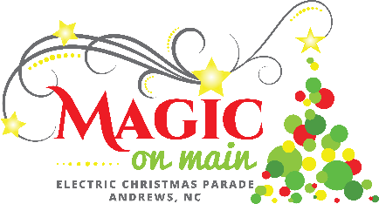
FOR IMMEDATE RELEASE Contact: Nola Cooper
Phone: 828-541-2765
Email: marketing@andrewschamber.com

CHANGES COMING TO LOCAL CHRISTMAS PARADE
COVID-19 and other safety concerns prompt adjustments
Andrews, North Carolina, October 20, 2020 – The Magic on Main Electric Christmas Parade will go on this year, but not without some significant changes.
CHANGE ONE: The biggest change this year will be the disbursement of candy. Parade floats will not be throwing candy to parade goers in 2020. In lieu of candy throwing the Andrews Chamber of Commerce will be filling candy bags and passing those bags out to children before, during, and after the parade. The bags will be passed out by Parade Marshals patrolling Main Street.
The decision for this change was two-fold:
- Float drivers and parade management have noticed a trend toward children jumping into the street to get the best candies. This is unsafe for those children, and very stressful for float drivers and parade management; causing the entire parade to slow down and have gaps.
- COVID-19 uncertainties mean that candies thrown and then picked up from the ground are questionable. The Andrews Chamber will fill the bags with store-bought candies using gloves and masks. The bags will be handed out using a “touch-free” bag hook method.
CHANGE TWO: Main Street Downtown will close early at 3pm for Shop Where Your Heart Is, from Walnut Street to Cherry Street. November 28, 2020 is national Shop Local Saturday, and we have added this small event before the parade to give visitors a chance to shop for Christmas at our wonderful local businesses. Be sure to also grab some food & drink and pick a good spot that allows for social distancing from others during the parade.
CHANGE THREE: For safety, the Magic on Main Electric Christmas Parade will end at the Ingles parking lot this year. This will allow local folks who are headed to work or other activities easy access to get around town via Whitaker Lane.
It is important to remember that Main Street will have rolling closures from 5pm to 8pm from the intersection at Walgreen’s (Whitaker Lane) to the Entrance of Industrial Opportunities Inc. (IOI). Keep in mind that the closing of Main Street is not only for the safety of parade participants and parade watchers, but is essential for the safety of residents, as well.
Andrews Chamber of Commerce President, Gayle Horton says “The Chamber feels that with these changes, parade goers will be able to safely social distance themselves during the parade by keeping to their own groups. Having the candy bags for the kids will cut down on interaction with others. Parade participants are naturally social distanced by the layout of the parade. We are looking forward to the opportunity to provide some much-needed Holiday entertainment for everyone in the area.”
The November 28 event, presented by Erlanger Western Carolina Hospital and sponsored by the Andrews Chamber of Commerce and the Town of Andrews will kick-off at 3:00 pm downtown, and the parade will begin at 5:30 pm. The parade will be broadcast by Tim Radford and WKRK Radio on Facebook live for those who cannot attend the event in person.
Learn more about the parade, and fill out your entry form at www.visitandrewsnc.com/magic-on-main/
###

